AI-Based Smart Waste Management and Classification System
Software Requirements Specification

Version 1.0


Supervisor Name: Anam Naveed

Project ID:F25PROJECT67B54

Submitted By: iqra jamil (BC220200221)

Revision History
Date (dd/mm/yyyy) | Version | Description | Author
28-Nov-2025 | 1.0 | This phase was about understanding the problem and shaping the system. I Collected the functional and non-functional requirements, drew up the user/admin roles with regards to their interaction with the system and sketched an overall workflow. And then I made up the use case diagram and usage scenarios to demonstrate how each feature behaves.  For methodology, I followed the same hybrid version you’ve used previously which is : a Waterfall-style overall direction and then Spiral approach within complex phases such as model training, dataset handling, and image classification.  The sequence concluded with planning artifacts like timeline and phase breakdowns. | BC220200221

Table of Contents
1.0 ABSTRACT / INTRODUCTION: 4
2.0 PROJECT PURPOSE: 4
3.0 SCOPE: 4
4.0 Functional Requirements and non-Functional Requirements: 5
4.1 Functional Requirements: 5
4.2 Non- Functional Requirements: 6
5.0 Use Case Diagram: 8
5.1 Usage Scenarios: 8
6.0 ADOPTED METHODOLOGY: 12
6.1 VU Process Model (Selected Methodology) 12
6.2 Why This Model Fits THIS System 13
6.3 Waterfall Model (Sequential Phases) 13
6.4 Waterfall Components Used 14
6.5 Spiral Model (Iterative Cycles) 14
6.6 How the Hybrid Model Works 16
6.7 Hybrid Approach (Waterfall + Spiral) 16
7.0 Work Plan: 17

ABSTRACT / INTRODUCTION:
Waste storing has always been a dirty problem. People throw junk into the wrong bins, Slowing recycling and making manual storing slow and even sometimes unsafe. The project attempts to address that problem by using artificial intelligence and computer vision to automatically detect what type of waste an item belongs to.
The system takes a picture or uploads an image of a waste item(images acquisition), and runs it through the pre- trained CNN model, and classifies it as plastic, organic, glass, metal, paper, or “other.” After classification, it suggests the right disposal or recycling method. The idea is to make the process easier for homes, schools, and public institutions that want a smarter way to deal with trash. It cuts down on mistakes, speeds up segregation, and encourages people to dispose of waste responsibly.

PROJECT PURPOSE:
The goal is simple: let AI handle waste sorting so it’s fast, accurate, and easy for everyone. Right now, people spend too much time guessing where their trash goes and usually get it wrong. Recycling centers end up with all sorts of mixed-up garbage because there’s no real help when you’re actually throwing stuff away.
This system changes that. It tells you exactly what kind of waste you’ve got and what to do with it. Meanwhile, admins can update the datasets, retrain the AI, and keep an eye on system’s performance

SCOPE:
This project covers image-based waste classification using a trained AI model and a simple interface that allows users to upload or capture waste images. The application handles preprocessing, classification, confidence scoring, disposal recommendations, and history tracking.
On the admin side, the system offers dataset management, model retraining, and classification logs for performance monitoring.
In real-world usage, this system helps the community by reducing incorrect waste disposal, which is a major issue in homes, schools, and public places. Many people are unaware of proper waste categories, which leads to mixing recyclable and non-recyclable waste. This system provides instant guidance, allowing users to make correct decisions at the moment of disposal. As a result, it improves recycling efficiency, reduces environmental pollution, and promotes responsible waste handling behavior.
The system is especially useful in areas where awareness and proper waste management facilities are limited. It can be used as an educational tool for students and households to learn correct waste segregation practices. By simplifying the process, it encourages more people to participate in environmentally friendly actions without requiring technical knowledge.
Compared to existing solutions, this system provides a more accessible and user-friendly approach. Many current systems depend on manual sorting, expensive hardware setups, or IoT-based smart bins, which are costly and not widely available. In contrast, this project is purely software-based and works with a simple device like a mobile phone or computer. It removes the need for specialized equipment and makes smart waste classification available to a wider audience.
Out of scope, real-time hardware-based sorting machines, robotic arms, IoT bins, and full environmental analytics. The system limits itself to software-based recognition and guidance only.

Functional Requirements and non-Functional Requirements:

Functional Requirements:

FR-01 Upload Waste Image
The system must let users to upload an image of a waste item directly from their device storage. The file goes through a validation step to check it is an acceptable image format. This feature helps users submit waste items easily without needing external tools or complicated steps.

FR-02 Capture Image Using Camera
The system must let users take a real time photo of a waste item using a built-in camera feature. This helps user when users want quick classification without browsing files. The captured image is automatically prepared for further processing.

FR-03 Validate Image Format
The system must verify that the input file is a supported image type like JPG, PNG, or JPEG. Invalid or corrupted files should be rejected immediately. This prevents processing errors and protects the AI model from unsupported data.

FR-04 Preprocess Image
Once a valid image is received, the system must resize, clean, and normalize the image before classification. Pre-processing keeps inputs consistent and helps the to work efficiently even if user images differ in size or quality.

FR-05 Classify Waste Using CNN Model
The core function is to classify waste into one of the predefined categories: Organic, Plastic, Glass, Metal, Paper or Other. The model must provide a clear category along with a confidence level. This classification drives the recommendations shown to the user.

FR-06 Display Classification Result
After processing and classification, the system must show the final category and its confidence score on the user interface. The result should be clear and easy to understand, so users can quicklyidentify the type of waste.

FR-07 Provide Disposal Recommendation
The system must generate disposal or recycling guidance based on the predicted waste category. Organic waste should lead to composting advice, recyclable materials should point to correct recycling bins, and hazardous materials should trigger warnings or special handling instructions. This helps users take correct action after classification.

.

FR-08 View Classification History
The system must let users view their previously classified waste items. Each entry should show the image, the predicted category, and classification time. This helps users track their activity and revisit past results whenever needed.

FR-09 Prevent Invalid File Uploads
The system must block the uploading of non image files .This includes PDFs, documents, text files, videos, and any unsupported formats. Preventing invalid inputs avoids unnecessary processing and keep the system stable.

FR-10 Do Not Store Personal Data
The system must operate without saving any personal information. Only the classified images and their results may be stored, and even those remain non-sensitive. This ensures privacy and keeps system operations simple and secure.

FR-11 Admin Add Training Dataset
The system must allow the admin to upload new images to expand the training dataset. Each newly added item should be stored in its correct category folder so the model can use it in the next training cycle.

FR-12 Admin Update Dataset or Retrain Model
The system must allow the admin to retrain the classification model whenever the dataset grows or quality improvements are needed. Retraining should update the model weights and improve accuracy based on newly added images.

FR-13 Log Classification Results
The system must maintain internal logs of all classifications performed. These logs may include timestamps, predicted categories, and confidence scores. This helps with monitoring system performance and detecting potential weaknesses.

FR-14 Provide Model Evaluation Report
After retraining, the system must generate a model evaluation summary showing with metrics like accuracy, loss, precision, and recall. This report helps the admin decide whether the updated model is ready for deployment.

Non- Functional Requirements:

NFR-01 Performance
The system should classify an image and return the result within a reasonable time. Since the model runs in inference mode, it must handle image preprocessing and prediction efficiently, ideally completing the full process in a few seconds. This ensures that users can quickly proceed with proper waste disposal.

NFR-02 Accuracy
The classification model should maintain a reliable accuracy level based on the training dataset used for training. The system must consistently identify common waste types correctly and minimize misclassification. Higher accuracy not only builds user trust but also improves the effectiveness of waste segregation in real environments.

NFR-03 Usability
The interface should be simple and intuitive so that users of any age or background can easily interact with the system. Uploading images, capturing photos, reading results, and understanding disposal recommendations should feel straightforward. The layout must avoid confusion and provide a smooth experience without requiring technical knowledge.

NFR-04 Security
The system should block unauthorized access to admin features like dataset management and retraining. User uploaded images must be validated to prevent harmful or unsupported files. Passwords or admin access mechanisms should remain protected to safeguard the integrity of the model and dataset.

NFR-05 Compatibility
The system should work reliably on commonly used browsers and devices. Whether accessed from a desktop, laptop, or mobile device, the interface and functions should remain stable. This enables the system accessible to all users groups without needing installation of specialized software.

NFR-06 Maintainability
The application and AI model should be easy to update, modify, or expand over time. Developers should be able to add new dataset images, retrain the model, or enhance modules without restructuring the system. Clean code and modular design help keep the system maintainable and future-proof.

NFR-07 Reliability
The system must perform consistently even after repeated classifications. It should not crash, corrupt data, or become unstable when handling multiple requests. Reliable operation ensures users can depend on the system for routine waste classification tasks.

NFR-08 Availability
The system should remain accessible during normal usage hours with minimal downtime. maintenance, model updates, or dataset changes should be scheduled to avoid interrupting regular users. High availability ensure smooth operation for homes, schools, and public facilities.

NFR-09 Data Integrity
All stored data , including classification history, dataset images, and model outputs must remain accurate and free from corruption. The system should ensure that updates to the dataset or model do not damage existing files or affect past records. Preserving data integrity is essential for consistent performance over time.

NFR-10 Backup and Recovery
The system should maintain regular backups of key components like dataset, model weights, and logs. In case of failure or accidental deletion, these backups allow quick recovery without major loss. This protects the model’s training progress and ensures stability of future classifications.

Use Case Diagram:
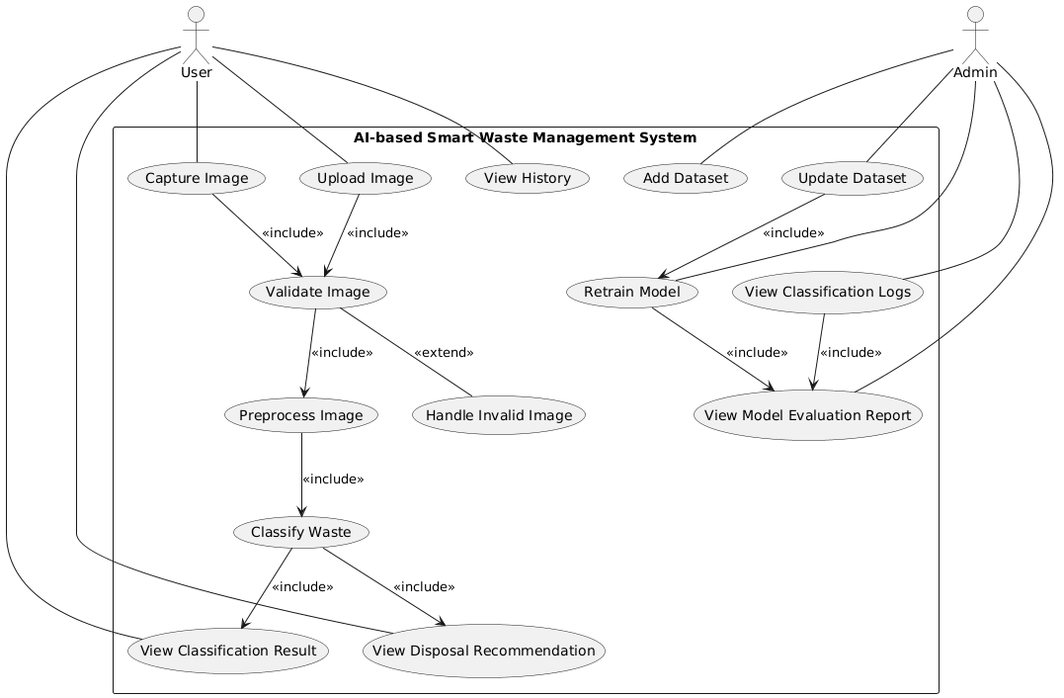

Usage Scenarios:

Use Case ID: SWMS-CAP-01

Use Case 1: Capture Waste Image
Field | Details
Author | BC220200221
Actor | User
Description | User captures an image of waste using device camera for classification
Precondition | Device must have a working camera and camera permission enabled
Post condition | Image is captured and stored temporarily for processing
Main Flow | • User opens camera interface  • User captures image of waste item  • System previews captured image  • System sends image for validation and processing
Alternative Flow | A1. User cancels capture. System returns to main screen  A2. User retakes image. System replaces previous image
Exception Flow | E1. Camera not accessible. System shows error  E2. Permission denied. System requests permission  E3. Capture fails. System asks to retry
Authority | User

Modification History
Date | Version | Description | Author
10-Dec-2025 | 1.0 | Initial creation of use case | Bc220200221

Use Case 2: Upload Image

Use Case ID: SWMS-UPL-02

Field | Details
Use Case | Upload Image
Actor | User
Precondition | User must have an image stored on the device
Main Flow | 1. User selects upload option.  2. Chooses an image from device storage.  3. System checks file type.  4. System forwards image for validation and processing.
Postcondition | Image uploaded successfully and ready for analysis

Use Case 3: View Classification Result

Use Case ID: SWMS-VAL-03
Field | Details
Use Case | View Classification Result
Actor | User
Precondition | System must have classified the waste image
Main Flow | 1. System displays waste category.  2. Shows confidence score.  3. User views result.
Postcondition | Result displayed to the user

Use Case 4: View Disposal Recommendation

Use Case ID: SWMS-PRE-04
Field | Details
Use Case | View Disposal Recommendation
Actor | User
Precondition | Classification result must be available
Main Flow | 1. System identifies waste type.  2. Shows disposal instructions (compost, recycle, etc).  3. User reads instructions.
Postcondition | User knows correct disposal method

Use Case 5: View History

Use Case ID: SWMS-CLA-05
Field | Details
Use Case | View History
Actor | User
Precondition | User must have previously classified images
Main Flow | 1. User opens history section.  2. System loads past classifications.  3. User views previous results.
Postcondition | History displayed

Use Case 6: Validate Image

Use Case ID: SWMS-RES-06
Field | Details
Use Case | Validate Image
Actor | System
Precondition | Image is captured or uploaded
Main Flow | 1. System checks file format.  2. Checks resolution/clarity.  3. Confirms it is a valid image.
Postcondition | Valid images proceed to pre-processing

Use Case 7: Pre-process Image

Use Case ID: SWMS-REC-07
Field | Details
Use Case | Pre-process Image
Actor | System
Precondition | Image is validated
Main Flow | 1. System resizes image.  2. Normalizes and cleans noise.  3. Prepares data for model input.
Postcondition | Cleaned image is ready for classification

Use Case 8: Classify Waste

Use Case ID: SWMS-HIS-08
Field | Details
Use Case | Classify Waste
Actor | System
Precondition | Image is pre-processed
Main Flow | 1. CNN model loads image.  2. Predicts waste category.  3. Generates confidence score.  4. Stores result.
Postcondition | Classification result generated

Use Case 9: Handle Invalid Image

Use Case ID: SWMS-BLK-09
Field | Details
Use Case | Handle Invalid Image
Actor | System
Precondition | Image fails validation
Main Flow | 1. System detects low-quality or wrong format.  2. Attempts automatic reprocessing.  3. If still invalid, notifies user.
Postcondition | User notified OR image reprocessed

Use Case 10: Add Dataset

Use Case ID: SWMS-PRV-10
Field | Details
Use Case | Add Dataset
Actor | Admin
Precondition | Admin must be authenticated
Main Flow | 1. Admin uploads new dataset images.  2. System stores and indexes them.
Postcondition | Dataset added to training pool

Use Case 11: Update Dataset

Use Case ID: SWMS-ADT-11
Field | Details
Use Case | Update Dataset
Actor | Admin
Precondition | Existing dataset must be available
Main Flow | 1. Admin edits or replaces dataset files.  2. System updates stored dataset.
Postcondition | Dataset refreshed

Use Case 12: Retrain Model

Use Case ID: SWMS-TRN-12
Field | Details
Use Case | Retrain Model
Actor | Admin
Precondition | Dataset must be updated or added
Main Flow | 1. Admin initiates model training.  2. System retrains CNN.  3. Generates new model.
Postcondition | Updated model ready for deployment

Use Case 13: View Classification Logs

Use Case ID: SWMS-LOG-13
Field | Details
Use Case | View Classification Logs
Actor | Admin
Precondition | System must have stored logs
Main Flow | 1. Admin opens logs panel.  2. System displays classification history.
Postcondition | Logs viewed successfully

Use Case 14: View Model Evaluation Report

Use Case ID: SWMS-EVL-14
Field | Details
Use Case | View Model Evaluation Report
Actor | Admin
Precondition | Model must be trained
Main Flow | 1. Admin requests evaluation report.  2. System generates metrics (accuracy, loss, confusion matrix).
Postcondition | Report displayed

ADOPTED METHODOLOGY:

VU Process Model (Selected Methodology)
The VU Process Model is selected for this project because it provides a structured development flow while still allowing controlled flexibility during development. It combines a clear phase based approach with the ability to refine complex parts of the system when required.
This model fits the project because the system has both fixed and evolving components. The application features such as image upload, camera capture, user interface, history, and admin panel follow a stable and predictable structure. These parts can be developed in a clear sequence without major changes, which aligns with the structured flow of the VU Process Model.
At the same time, the AI based classification component requires continuous improvement during development. The model performance depends on dataset quality and training adjustments, which may require refinement during implementation. The VU Process Model supports this by allowing iterative improvement within development phases while still maintaining overall project structure.
This model is better than Waterfall because Waterfall is too rigid and does not handle changes during development effectively. It is also better than purely iterative models because those can lead to lack of structure and unclear progress tracking. The VU Process Model balances both approaches by keeping a clear roadmap while still supporting necessary refinements.
Overall, it ensures proper documentation, controlled development stages, and flexibility where needed, making it suitable for an AI based system like waste classification.
.

Why This Model Fits THIS System
Your system has specific needs:
System Requirement | Why Hybrid Model Fits
Image capture and upload | These are fixed UI functions → Waterfall handles them cleanly.
Validation, pre-processing, classification | These need improvement and tuning → Spiral handles iterative refinement.
Waste category accuracy | Accuracy is never final in one attempt → Spiral handles multiple model training loops.
Admin dataset updates | New dataset = new training loop → Spiral naturally adapts.
History, logs, UI screens | Stable modules → Waterfall builds them once without rework.
Deployment of trained model | Waterfall gives a clear final release stage.

Waterfall Model (Sequential Phases)
Overview:
Waterfall provides the project a clear top-down flow. You start by defining the requirements, then design the system, build it, test it, and finally deploy it. Each phase has a start and an end, which helps in documenting progress or reporting to supervisors.
Since the main functions, classification, UI, admin panel, dataset handling are well-defined, a sequential flow works smoothly
Advantages:
- Each stage produces clear outputs (SRS, design diagrams, trained model, UI, final system).
- Easy to track progress because everyone knows what phase they’re in.
- Works well for the non-AI parts of the project: interface, admin features, history module, logs, etc.

Waterfall Components Used
Waterfall Phase | Components Used
Requirement Analysis | Identify inputs (images), outputs (categories, confidence), admin functions, system restrictions.
System Design | Design UI, workflows, dataset storage, model integration pipeline.
Model/Data Design | Choose CNN architecture, pre-processing methods, supported waste categories.
Implementation | Build UI, history module, logs, admin dashboard, integrate trained model.
Testing | Test classification speed (≤5 sec), accuracy, UI usability, file validation.
Deployment | Host web system + trained model for real-time classification.

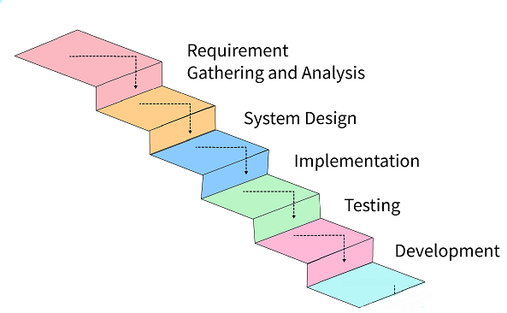

Spiral Model (Iterative Cycles)
Overview:
While Waterfall organizes the project, Spiral refines the tricky parts , especially the CNN model, dataset quality, pre-processing pipeline, and prediction accuracy.
Each Spiral loop begins with identifying risks, followed by prototyping, then testing, and then improving.
Advantages:
- You catch mistakes early instead of at the end.
- Model weaknesses (like misclassifying metal as plastic) can be fixed through multiple cycles.
- Dataset issues — imbalance, unclear images, noise — can be corrected immediately.
- Reduces wasted time because you’re improving only the areas that actually need work.

Spiral Components Used
Spiral Stage | Components
Risk Identification | Identify weak classes (plastic vs metal errors), dataset imbalance.
Risk Evaluation | Check confusion matrix, low-confidence predictions.
Prototyping | Try new pre-processing, add new dataset images, adjust CNN layers.
Testing | Evaluate accuracy, test sample images, compare models.
Iteration | Retrain model until accuracy is acceptable.
Planning Next Cycle | Plan next dataset update or pre-processing improvement.
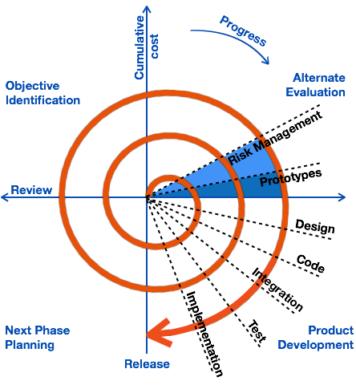
This cycle repeats until the module is complete and stable.

How the Hybrid Model Works
Waterfall (Top-Level Flow)
Used for:
- UI screens
- Upload system
- History module
- Admin panel
- System workflows
- Deployment
These modules don’t change much, so Waterfall gives a predictable roadmap.
Spiral (Inside Implementation & Testing)
Used for:
- Dataset improvement
- Pre-processing tuning
- CNN retraining
- Accuracy enhancement
- Performance optimization
Every time accuracy is low, the Spiral loop runs again.

Hybrid Approach (Waterfall + Spiral)
This system works best when Waterfall managing the overall roadmap and Spiral handling the smaller loops inside critical modules.
the hybrid structure works like this:
- The overall project moves Waterfall-style from requirements → design → implementation → testing → deployment.
- The AI parts — especially model training, dataset improvement, and pre-processing — run in Spiral loops inside the implementation and testing phases.
This keeps the project grounded but still flexible where it needs to be.
Benefits:
- Maintains clarity and structure for documentation.
- Reduces the risk of poor AI accuracy.
- Makes it easier to incorporate new dataset images.
- Helps achieve a more polished and reliable model.
- Gives room for adjustments without breaking the entire workflow.

Key Roles in the Hybrid Model
Role | Responsibility
Project Manager | Keeps development aligned with the plan and timeline
System Analyst | Defines the scope, requirements, and system flow
AI Engineer | Builds and refines the CNN model, manages dataset quality
UI/UX Designer | Designs a clean and usable interface for classification and admin tools
Developer | Implements system modules and integrates the AI model
QA / Test Engineer | Tests the UI, performance, and classification correctness
DevOps Engineer | Handles deployment and server configurations
Risk Analyst (Spiral Focus) | Tracks model performance issues, accuracy drops, dataset risks

Work Plan:
